1.

from matplotlib import pyplot as plt

year=[2015,2016,2017,2018,2019]

rain=[100,60,120,50,20]

plt.plot(year,rain)

Output:

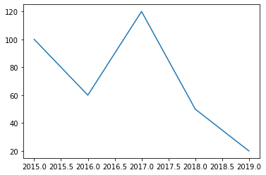

2.

from matplotlib import pyplot as plt

import random

age=[]

for i in range(50):age.append(random.randint(25,60))

plt.hist(age,bins=8,range=(25,60),color='green')

Output

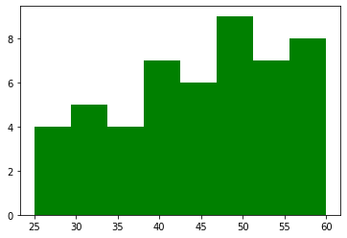

3.

from matplotlib import pyplot as plt

import random

student=[]

grade=[]

for i in range(60):student.append(random.choice(['A','B','C','D','O','E']))

for i in ['A','B','C','D','O','E']:grade.append(student.count(i))

plt.bar(['A','B','C','D','O','E'],grade)

Output

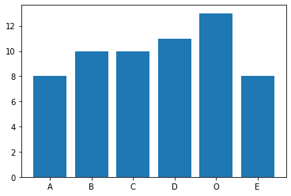

4.

from matplotlib import pyplot as plt

years=[2010,2012,2014,2016,2018,2020]

agr=[10,20,30,50,15,5]

ind=[90,50,60,70,20,10]

plt.plot(years,agr)

plt.plot(years,ind)

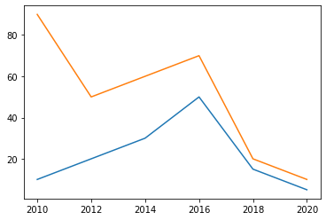Output

5.

import matplotlib.pyplot as plt

import random

hobbies=['singing','dancing','reading','programming','hacking']

student=[]

fr=[]

for i in range(60):student.append(random.choice(hobbies))

for i in hobbies:fr.append(student.count(i))

plt.pie(fr, labels=hobbies,

colors=['red','green','yellow','lightcoral', 'lightskyblue']

,autopct='%1.1f%%')

Output

